Q2 / Sarcoma Reviewed by NV
Stem:
A 55-year-old male presents to your office after being referred from his PCP for further valuation of an asymptomatic mass on his right inner thigh.

PMH: None. Family history is noncontributory.

PE: There is poorly defined posterior right thigh mass, approximately 8 cm in diameter (specify compartment, posteromedial in this case based on picture, involving the hamstrings)

Labs: Not significant.

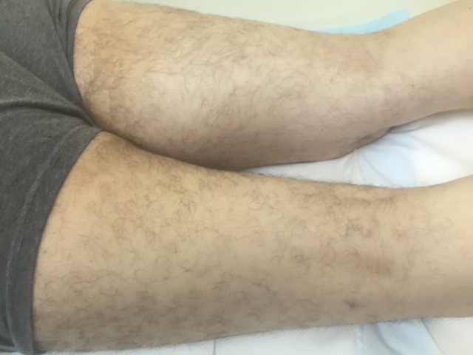
Describe how you would work up and manage this mass?
1. Plain radiograph of the thigh:Soft tissue mass with fat density (Need to start with plain radiograph to r/o periosteal or bone involvement)
2. MRI of the entire muscle compartment:soft tissue mass, with low signal intensity on T1 and high signal intensity on T2
3. Obtain image-guided core needle biopsy with multiple passes of 18g needle with site incorporated into possible resection margin →pathology: high grade pleomorphic sarcoma
4. Staging workup: CT of chest
What if the core needle biopsy came back as non-conclusive? -à Obtain incisional biopsy -à describe Technique. -à Along the axis and don’t develop fascial planes.
Mass is high grade; how would you approach this mass from an operative standpoint?
Radiate first
1. limb salvage.
2. Excision outside the pseudocapsule.
3. Radical resection of the muscle compartment Preserve sciatic
When is amputation indicated? -à Inability to resect without amputation,
nonfunctional limb
A 32-year-old man with a history of FAP presents with a 15-cm firm mass in the right axilla that restricts his range of motion. A CNB confirms a desmoid tumor, imaging doesn’t show nerve involvement, patient requests excision, how would you council them regarding risk of recurrence. ?
- >50% chance of recurrence even with R0 resection
What if the mass was asymptomatic?
a. Observe.
b. Consider medical management with sulindac or other NSAIDs or tamoxifen.
What if this was a 32-year-old female and the mass was discovered during
pregnancy?
a. Post-partum give sulindac or tamoxifen or observe.

Q3 / Pancreatic Pseudocyst
Stem:
43-year-old man presents to your office after a recent admission 2 weeks ago for acute pancreatitis. He continues to have abdominal discomfort.

Social Hx: Alcohol abuse but has abstained since admission.

Physical Exam: T=98 degrees, BP=140/60, HR 88, and RR of 18. Abdominal exam shows that he is mildly tender to palpation in the left upper quadrant without guarding or peritoneal signs.

What imaging you would like to order?
- RUQ ultrasound shows a fluid collection in the left upper quadrant.
- CT scan:Shows peripancreatic inflammation, and has a 5 cm fluid collection along the pancreatic body/tail

What is your differential diagnosis?
- Pancreatic pseudocyst
- Serous cystadenoma
- IPMN
- Mucinous cystadenoma

What would you like to do now?
- Wait and watch. (Pseudocysts can develop in up to 10% of patients with acute pancreatitis. Majority will spontaneously resolve)

Scenario: Patient returns to office 2 months later with persistent symptoms of early satiety, nausea and occasional emesis. CT scan now shows 15 cm pancreatic body/tail cyst with thickened wall and compression of stomach. What to do now?
1. MRI/MRCP
2. Drainage:
- Internal drainage with cystogastrostomy – endoscopic vs surgical.
3. Surgical cystogastrostomy (open or lap). Describe open cystogastrostomy?
-Upper midline.
- cholecystectomy
- anterior gastrostomy, expose posterior wall.
- enter cyst through posterior wall.
- biopsy.
- Debride necrosis.
- Anastomosis, wide at least 5 cm.

If patient has splenic or portal vein thrombosis, what are you concerned about?
Perigastric varices can preclude cystogastrostomy.

Scenario: Original patient with pancreatic pseudocyst gets admitted to hospital with abdominal pain, fever, and leukocytosis. CT showsMultiple pockets of air within pseudocyst cavity. Patient becomes hypotensive and is transferred to ICU. He continues to worsen clinically and is now intubated and on pressors. How to proceed?
- IV Abx
- Abscess cavity drainage.
- Pancreatic necrosectomy.

Q1/ Complex Liver Injury
Stem:
A 31-year-old man presents to the emergency department via emergency medical services (EMS) after an assault and being kicked. On arrival, he opens his eyes spontaneously, follows commands, and is oriented. He has bilateral and equal breath sounds and palpable peripheral pulses. His initial vital signs include systolic blood pressure (SBP) of 110 mm Hg, heart rate (HR) of 89, respiratory rate of 26, and oxygen saturation of 98%. He has right upper quadrant tenderness associated with a large contusion of the right upper quadrant and flank. Chest x-ray is negative. Pelvic x-ray demonstrated a right pelvic fracture. A focused assessment with sonography for trauma (FAST) demonstrates fluid in the right upper quadrant.
What is most likely diagnosis?
- S olid organ injury
- H ollow viscus injury.
- E xtraperitoneal hemorrhage
What is your plan?
- P rogresses through the primary and secondary surveys
- C est x-ray, pelvic x-ray, and FAST exam
- CT A/P.
Free fluid in the abdomen on FAST, and pelvic fracture on plain radiograph, Patient remains hemodynamically stable and CT showed :A grade IV liver laceration without active extravasation of intravascular contrast, Now what?
- ICU admission
- Non op management

The patient is admitted to the ICU. Five hours later he decompensates hypotension (SBP 89), and tachycardia (HR 110).
- Evaluate the patient immediately. (Abdominal exam, peritonitis)
- Transfusion
- OR for immediate laparotomy.Describe?
  - T rauma exploratory laparotomy—midline incision, evacuation of hemoperitoneum, packing of four quadrants
  - Sequential removal of packing after resuscitation
  - Evaluation of the extent of liver injury
  - Bimanual compression of liver to control hemorrhage
  - Circumferential packing of the liver to achieve tamponade; if hemorrhage is controlled, perform temporary abdominal closure after completion of abdominal exploration
  - Planned removal of packing at 48 h
  - Pringle maneuver when packing does not control hemorrhage
  - Direct vessel ligation to control bleeding; may require mobilization, finger fracture, or stapled hepatotomy
What would you suspect if Pringle maneuver does not control bleeding?
  - I njury to hepatic vein or retrohepatic vena cava when
You pack the patient and take him to the ICU, the patient remains stable with no hemodynamic or laboratory evidence of bleeding. At 48 hours, the patient returns to the OR for planned relaparotomy and removal of perihepatic packing. On removal of the laparotomy pads, there is significant bile staining on the pads, there is significant necrosis of segment VI, and hemorrhage from the injury ensues. Now what?
- Control the hemorrhage with bimanual compression.
- Rummel tourniquet around the porta hepatis, not tightened.
- Mobilize t he right lobe to expos e the injured liver.
- C holecystectomy
- Pringle is applied, and a nonanatomic resection of the injured liver.
Argon beam coagulator and topical cellulose hemostatic agents are used to control parenchymal bleeding from the liver edge.

